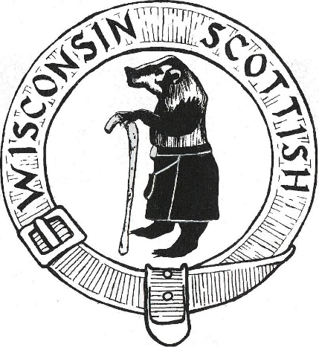
WISCONSIN SCOTTISH INC.
Presents
The 2026 Wisconsin Highland Games

Dear Clan Convenor,

The 2026 Wisconsin Highland Games will be held rain or shine at the Waukesha County Expo, 1000 Northview Road, Waukesha, WI on Friday evening Sept 4, Saturday, Sept 5 and Sunday Sept 6.
Please join us for our 25th year!!

Friday evening, we will have an opening ceremony to include THE CALLING OF THE CLANS!!
Be sure to check the box on the reservation form if you will be attending.

A reserved parking pass and two weekend admission passes are included with your Clan site for the price of $50.00. Please return the reservation form by August 16, 2026.

Once again this year we will have catered lunches available from Cousins Subs!
The forms are included with your Clan form and must be filled out for either one or both days of the games and payment must be included with the forms, one check for clan site(s) and lunch is fine.

Mention Wisconsin Highland Games Room Block when making reservations to ensure getting the group rate.
A block of rooms will be held until August 13th at:

Milwaukee Marriott West
W231N1600 Corporate Ct
Waukesha, WI 53186
Book your group rate for Wisconsin Highland Games Room Block 2026 by Aug 13th

Slainte!
Bree Callahan-Schaefer & Jon Young
Clan chairpersons
We can be contacted at aecallahan93@yahoo.com or
jonyoung@ameritech.net with any questions.

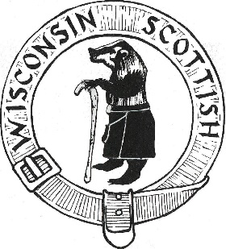 Wisconsin Highland Games
2026

Sept 4, 5 & 6, 2025

Waukesha County Expo Center

Clan Site Reservation Form

Clan/Society Name: _________________________________________________

Convener Name: ____________________________________________________

Address: ___________________________________________________________

City, State & Zip: ____________________________________________________

Phone Number: ____________________________________

Please check here if you would
like form emailed next year.
Email: __________________________________________

(Site Reservation includes two admission passes & one parking pass. Tents are not included)

Site Reservation: 10’x 10’: ____ X $50.00 ea. = $______

Additional Daily Tickets: ____ X $15.00 ea. = $______

Number of Chairs Required: ____ X $5.00 ea. = $______

Number of Tables Required: ____ X $10.00 ea. = $______
Total Enclosed $______
Please check here if Clan Representative will be participating in the Friday night Opening Ceremonies.

Special Requests:

Please make all checks payable to: Wisconsin SCOTTISH Inc.
4775 S. Langlade Drive
New Berlin, WI 53151

The Waukesha County Expo would like us to remind you that carry-ins are prohibited.

2026 WI HIGHLAND GAMES - ADVANCE ORDER LUNCH MEALS
All meals must be ordered and prepaid by August 16, 2026
Meals will be delivered between 11:30 am - 1:30 pm.
NAME: |  |  |  |  | CELL PHONE:
LOCATION: (i.e. Clan Name or Organization)
 |  |  | SATURDAY SEPT 5 |  |  |  | SUNDAY SEPT 6
Meal - Sandwich Plus:
Bag of Chips, Cookie, Bottle of Water
 | PRICE |  | QUANTITY |  | TOTAL DUE: |  | QUANTITY |  | TOTAL DUE:
Turkey Sub | $12.00 |  |  |  | $ |  |  |  | $
Club Sub | $13.00 |  |  |  | $ |  |  |  | $
Veggie Sub | $12.00 |  |  |  | $ |  |  |  | $
Ham & Provolone Sub | $12.00 |  |  |  | $ |  |  |  | $
Italian Sub | $13.00 |  |  |  | $ |  |  |  | $
 |  |  | Total for Saturday |  | $ |  | Total for Sunday |  | $
 |  |  | TOTAL AMOUNT DUE:
Check must be made out to WI Scottish Inc.
Orders without prepayment will not be honored.
 |  |  |  | CLAN Sandwich Orders may be combined with your CLAN site reservation form check

